- The spike in gilt yields in the first half of this week was another reminder of the fragility of the UK's fiscal situation. Though talk of a 1970s-style fiscal crisis exaggerates the scale of the problems, the UK is particularly vulnerable to swings in market sentiment. The Budget on November 26 is likely to see another substantial tightening of fiscal policy.
- The Office for National Statistics revealed that it had delayed publication of July's retail sales data to correct seasonal adjustment errors. The new profile removes some of the more erratic monthly movements in early-2025 and looks more believable. But it's hard to have much confidence in the data when such fundamental errors are being made, and the revisions are so large.
Fiscal policy has been back in the spotlight this week, with the Chancellor announcing the Budget date – November 26 – against a backdrop of gilt yields continuing to climb.
Much of the media attention has focused on the 30-year yield, which this week reached its highest level since the late-1990s. The increase in this portion of the curve appears to have been exaggerated by lower structural demand from pension funds. The rise in long-dated yields also has limited implications for financing government debt – since the government came to power last summer, only 3% of the gilts issued were at maturities of 30 years or more.
But there's also been a clear increase in yields across the middle of the curve, with the 10-year yield up nearly 40bps on the level seen after last year's budget (Chart 1). While recent media speculation that the UK could face a repeat of the 1970s IMF bailout exaggerates the scale of the UK's fiscal problems, the fiscal backdrop is fragile. The UK has one of the highest budget deficits in the G7, while history suggests that tax-based consolidations, like the one the government is pursuing, have a high failure rate. What's more, the UK cannot fall back on some of the favourable structural factors that allow other countries to fund higher debt levels.
Chart 1: Gilt yields have risen sharply over the past year, particularly at the longer end of the curve
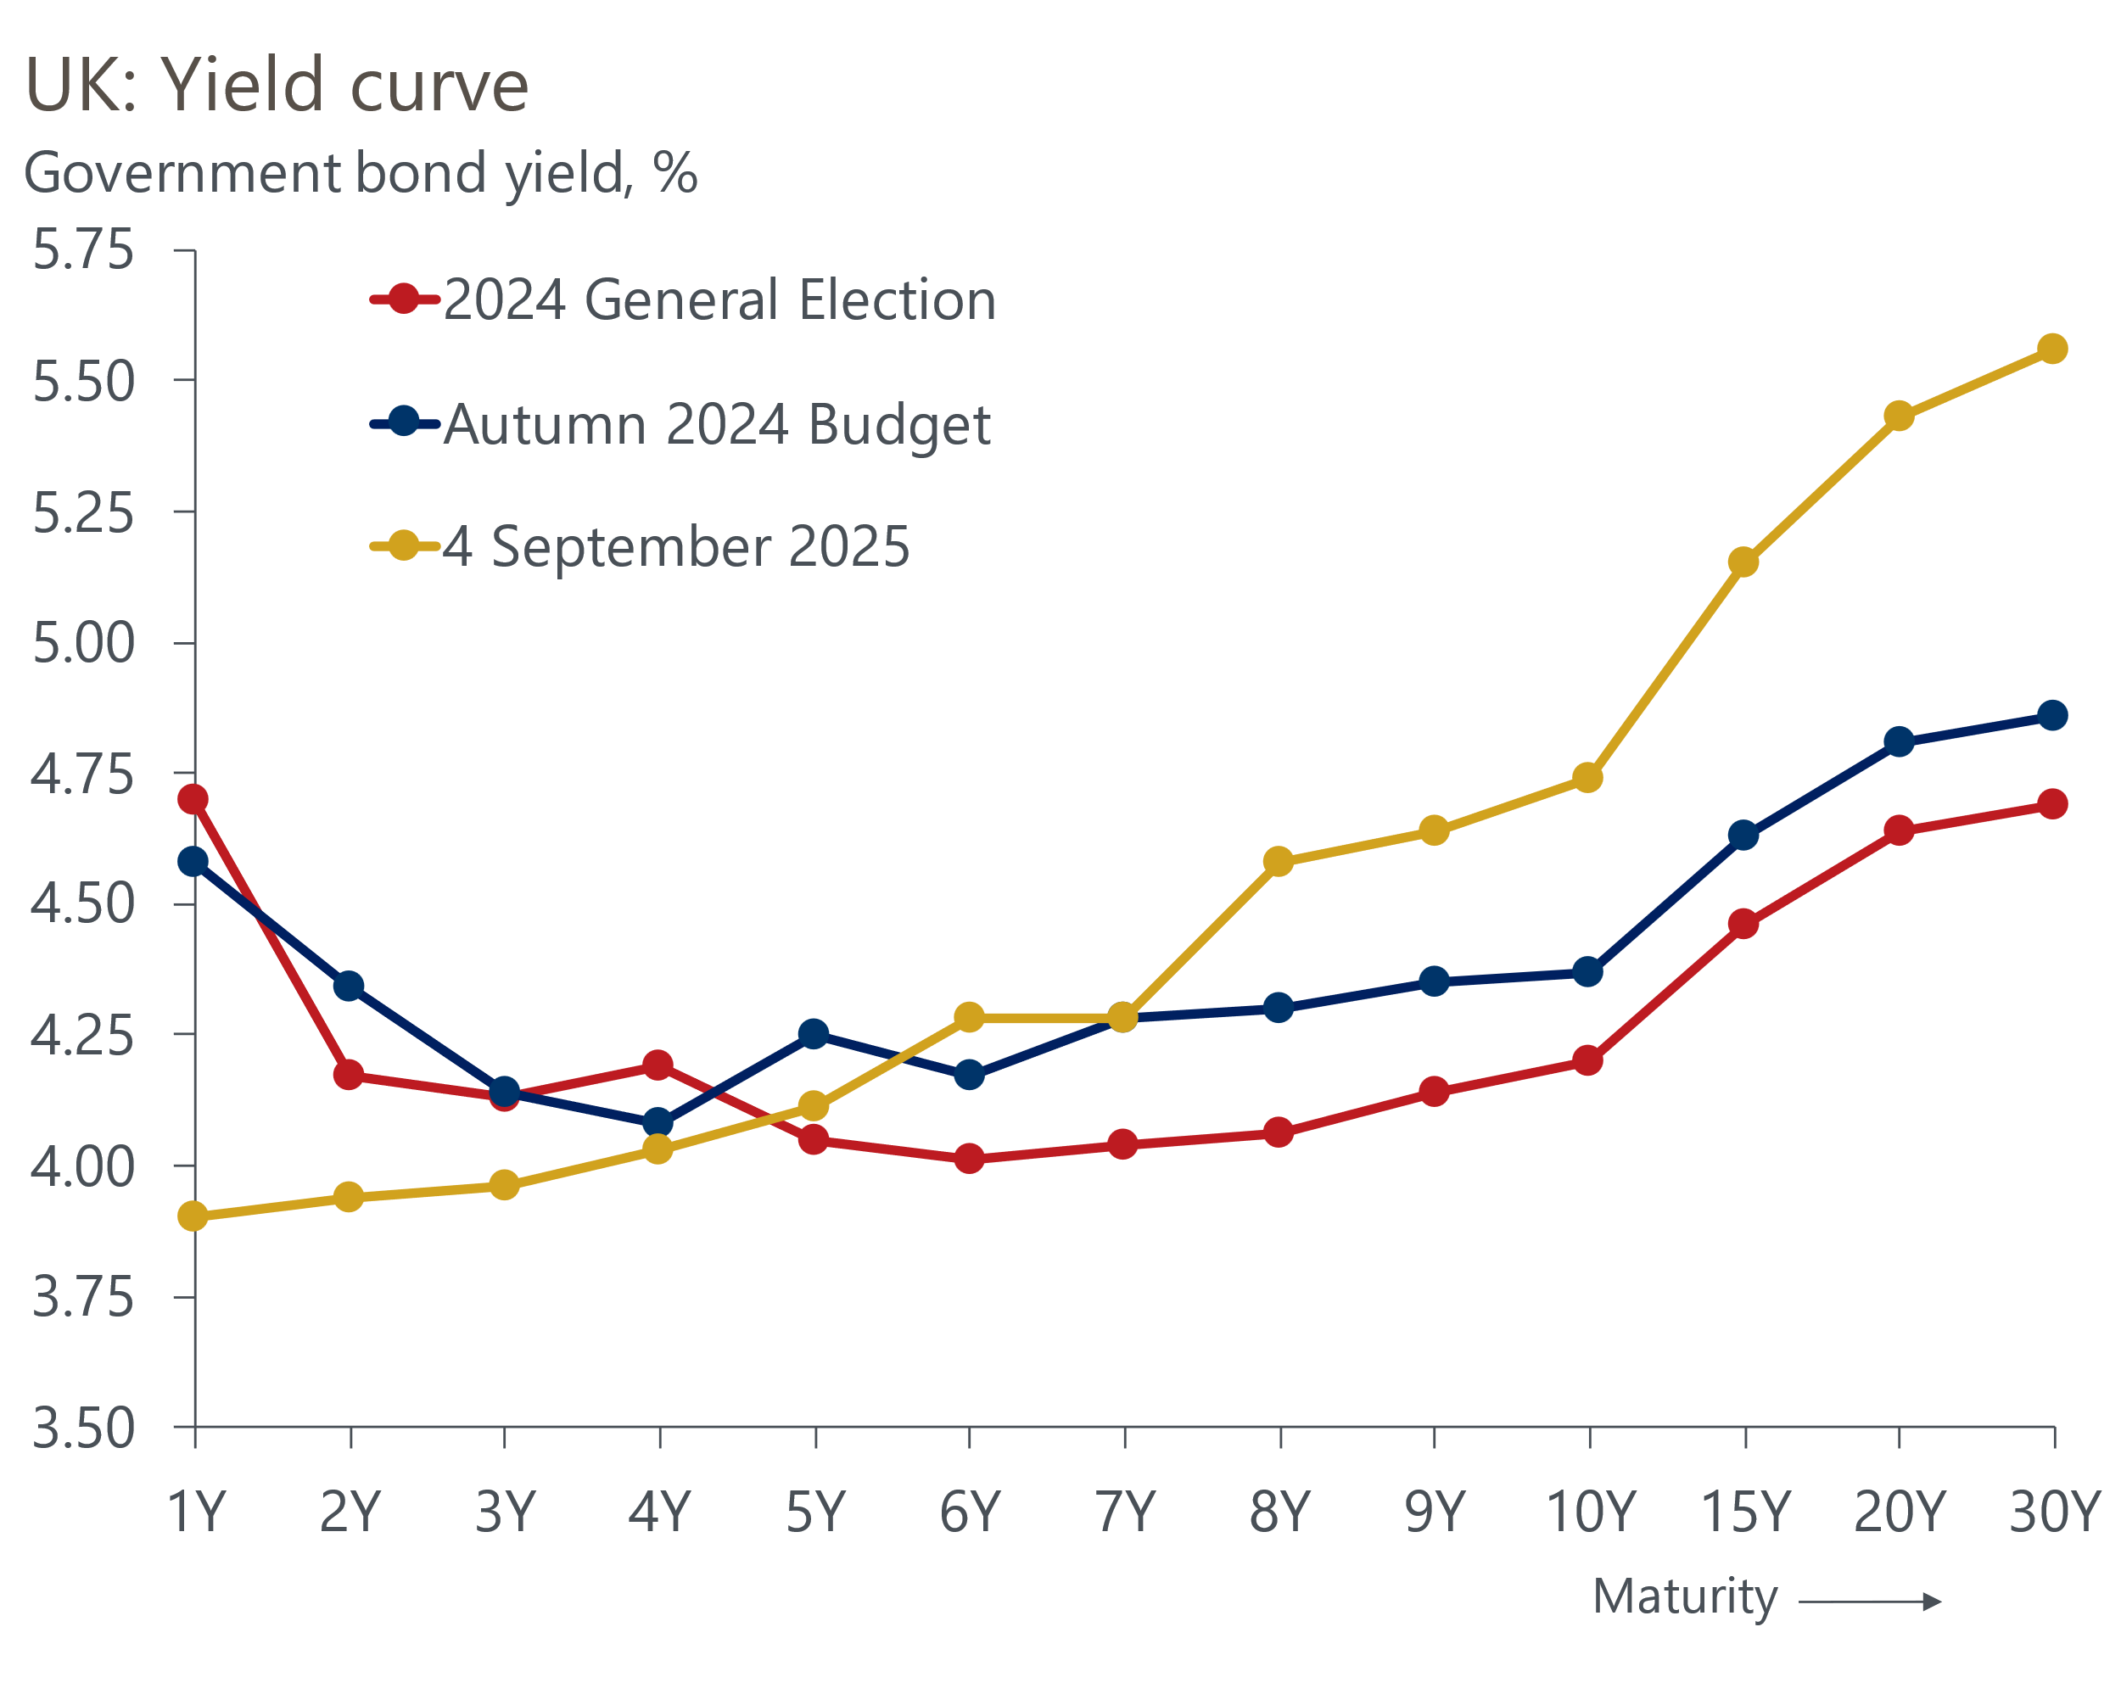
Source: Haver Analytics

At the margin, the latest increase in yields adds to the new tightening the Chancellor will need to come up with in the Budget. But the key factor will be the extent to which the Office for Budget Responsibility marks down its forecast for potential output growth. We think the likeliest outcome is that the Chancellor will need to find around £30bn of savings, which will almost exclusively come from tax hikes.
In a series of notes in the run-up to the Budget, we plan to look at the fragility of the UK fiscal situation, what measures the government is likely to implement in the Budget, and recommend what the government should do to rectify its fiscal problems.
Turning to monetary policy, this week's Treasury Select Committee hearing reinforced the view that the Monetary Policy Committee is deeply divided, with Governor Andrew Bailey occupying the middle ground. Bailey's testimony identified downside risks in the labour market as the key motivation behind his vote to cut in August. But he said he was keen to add a clear message on inflation risk and to emphasise there was more uncertainty over the timing and pace of future rate cuts.
Since the August meeting, markets have become more confident that the MPC will skip a cut in November, with latest pricing implying just a 16% chance of a cut by that meeting. If that holds, we think it unlikely that the Governor will be prepared to vote against market pricing, particularly given that any tightening of fiscal policy will not have been announced at that stage. So our September forecast will assume the MPC won't cut Bank Rate again this year, although the November and December decisions will likely be close calls.
Data quality issues have added to what is already a challenging situation for the MPC. Back in March, we published a note that looked at the various issues with Office for National Statistics data and identified the increasingly erratic month-to-month movements in retail sales as an obvious source of concern.
This week, the ONS revealed the reason it had delayed the release of July's retail sales data by two weeks was to correct seasonal adjustment errors. Most of the revisions related to the past year, with the level of sales cut in most months. The revisions to January (1.8ppts) and April (1.7ppts) were particularly large (Chart 2). The new profile looks more believable, but it's hard to have much confidence in the data when such fundamental errors are being made, and the revisions are so large.
Chart 2: The correction of seasonal adjustment errors caused massive revisions to retail sales estimates
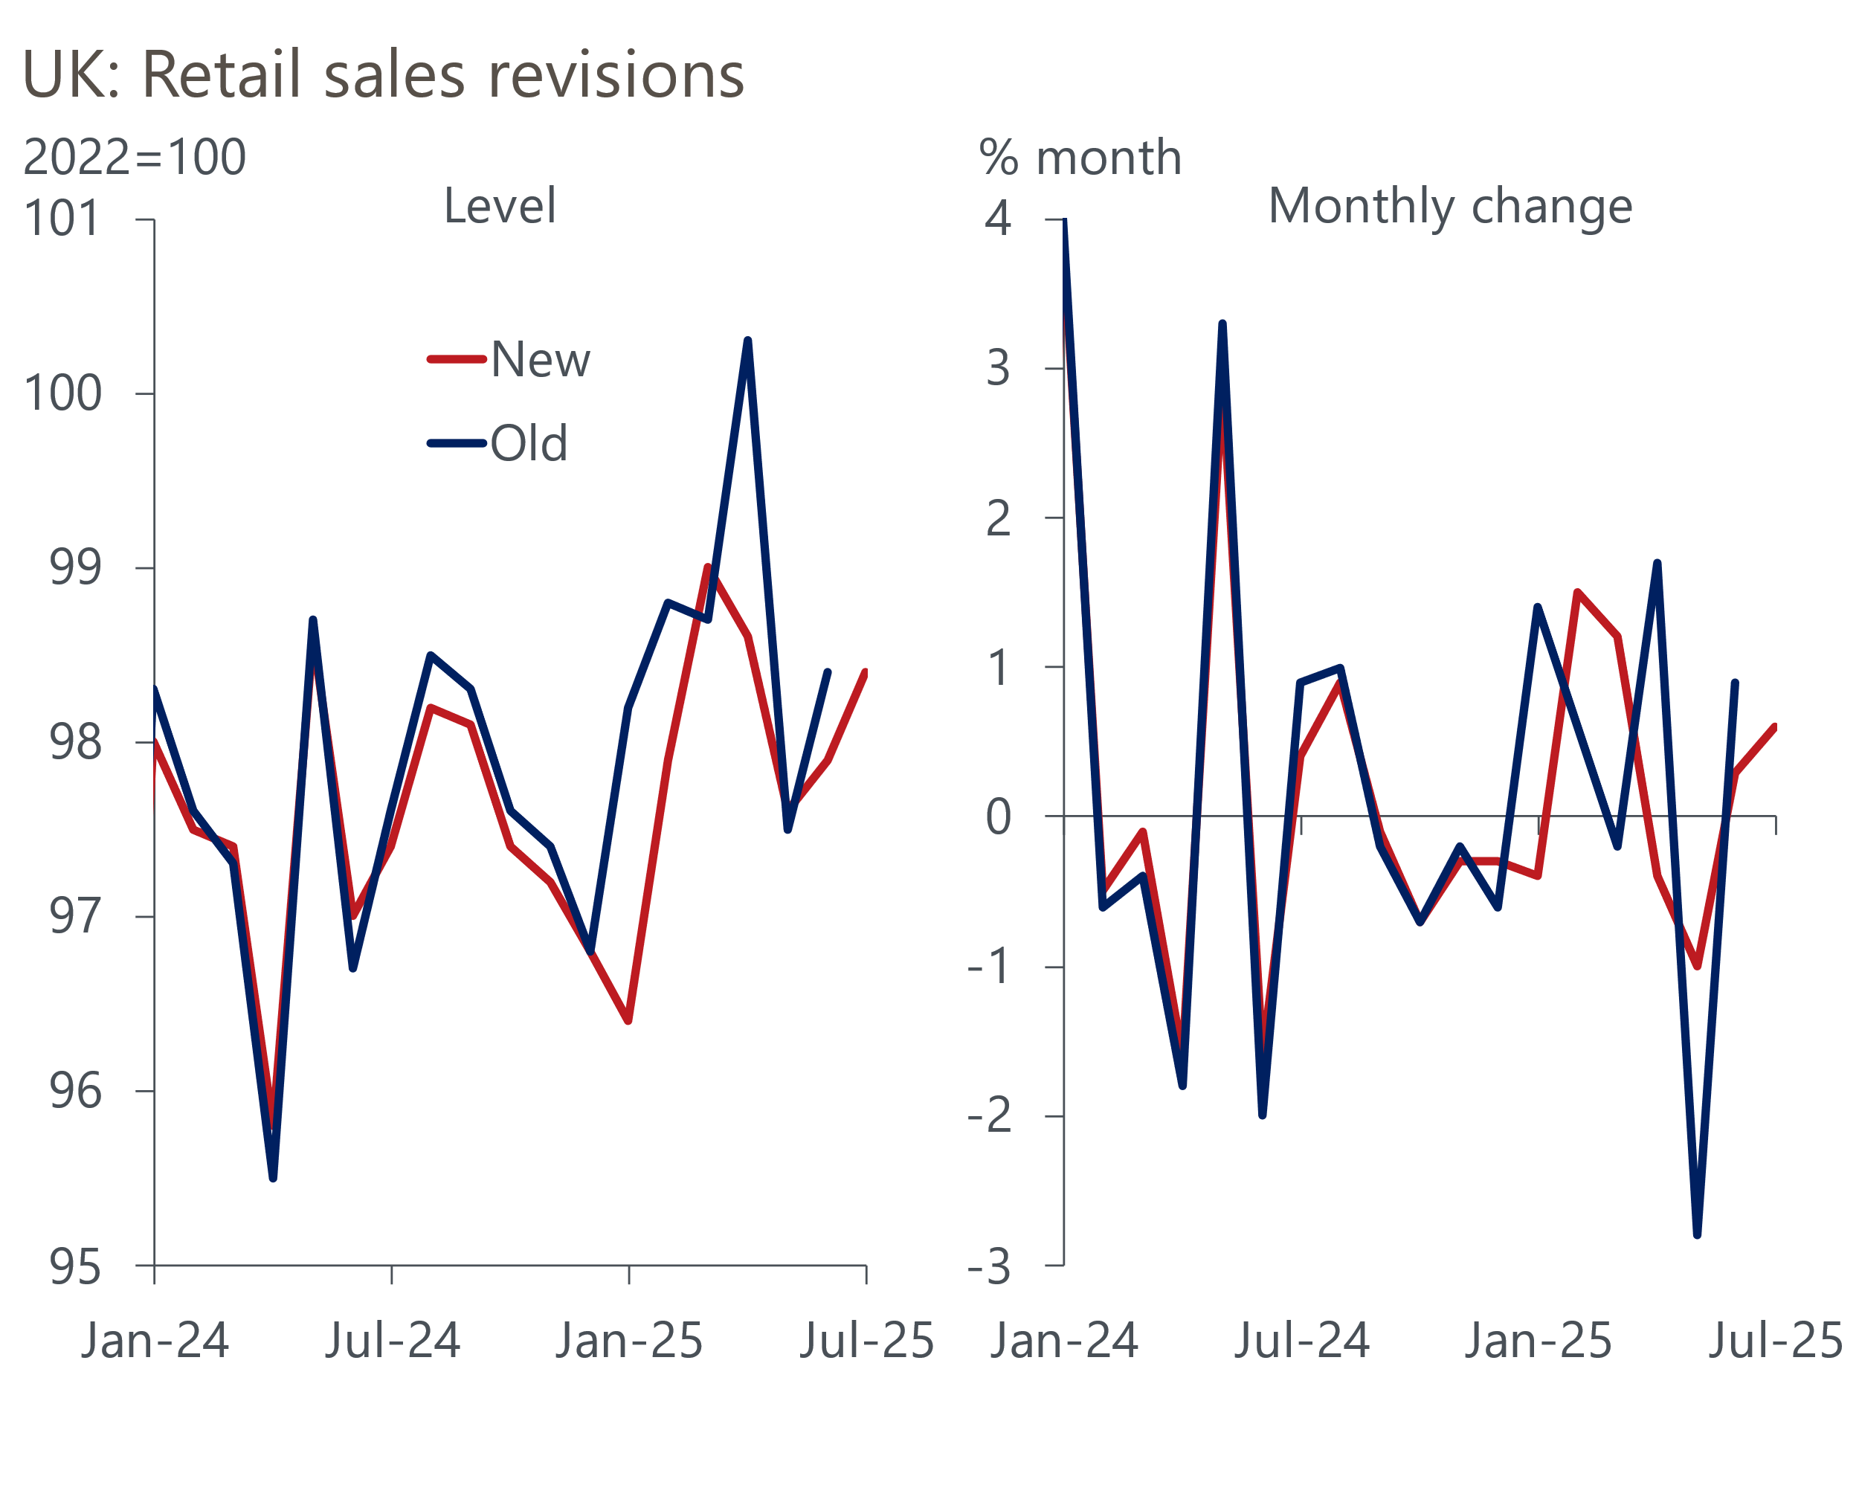
Source: Haver Analytics
We plan to publish a note next week that will look at what factors could convince the MPC to change tack and up the pace of rate cuts again. With retail sales rising 0.6% month-on-month in July and August's PMIs coming in stronger, the activity data looks unlikely to be a driver of change in the near term. Renewed signs of fragility in the labour market are a more obvious candidate, and this week's Bank of England Decision Maker Panel for August reported the fastest fall in employment for four years. But with the readings for prices and wages consistent with continued stickiness, it looks odds against a November rate cut at this stage.

The week ahead
Next week's only major release is the GDP data for July. June saw surprisingly strong month-on-month output growth of 0.4%, with the pickup relatively broad-based. We think there's likely to be some payback in July, with the recent strength of several sectors unlikely to be sustained. In addition, strikes by resident doctors at the end of the month are likely to have weighed on output of the health sector. But another chunky increase in retail sales suggests that distribution output is likely to have been resilient. So we expect only a partial correction of June's strength, with GDP expected to have fallen by 0.2% month-on-month in July.
Table 1: Week ahead calendar
Date | Events | Period | Measure | Unit | Previous | Forecast
Sep 12 | GDP | Jul | m/m | % | 0.4 | -0.2
Sep 12 | GDP | Jul | 3m/3m | % | 0.4 | 0.1
Sep 12 | Index of services | Jul | m/m | % | 0.3 | -0.2
Sep 12 | Index of services | Jul | 3m/3m | % | 0.4 | 0.3
Sep 12 | Manufacturing output | Jul | m/m | % | 0.5 | -0.4
Sep 12 | Manufacturing output | Jul | y/y | % | 0.0 | 1.2
Sep 12 | Industrial production | Jul | m/m | % | 0.7 | -0.3
Sep 12 | Industrial production | Jul | y/y | % | 0.2 | 0.8
Sep 12 | Construction output | Jul | m/m | % | 0.3 | -0.2
Sep 12 | Construction output | Jul | y/y | % | 1.5 | 1.9
Sep 12 | UK trade | Jul | Trade balance | £bn | -5.0 | -5.0
Sep 12 | UK trade | Jul | Visible balance | £bn | -22.2 | -22.0
Source: Oxford Economics

Key forecasts
Table 2: UK forecast overview
(Annual percentage changes unless specified)
 | 2023 | 2024 | 2025 | 2026 | 2027 | 2028
GDP | 0.4 | 1.1 | 1.3 | 0.9 | 1.3 | 1.7
Private consumption | 0.5 | 0.6 | 1.0 | 1.0 | 1.2 | 1.7
Fixed investment | 0.3 | 1.5 | 1.9 | 1.0 | 1.6 | 2.0
Government consumption | 1.6 | 3.0 | 1.8 | 1.8 | 1.6 | 1.7
Exports of goods and services | -0.4 | -1.2 | 2.2 | 0.2 | 1.2 | 1.4
Imports of goods and services | -1.2 | 2.7 | 3.9 | -0.9 | 1.1 | 1.4
Industrial Production | -0.8 | -1.2 | 0.3 | -0.4 | 0.8 | 1.2
Consumer prices | 7.3 | 2.5 | 3.5 | 2.9 | 2.5 | 2.1
Unemployment rate (%) | 4.1 | 4.3 | 4.7 | 4.9 | 4.8 | 4.4
Current a/c balance (% of GDP) | -3.5 | -2.7 | -3.3 | -3.1 | -2.9 | -2.8
Government balance (% of GDP) | 5.2 | 5.1 | 4.5 | 3.6 | 3.0 | 2.6
Central bank policy rate (%, EOP) | 5.25 | 4.75 | 4.00 | 3.50 | 3.00 | 2.75
10yr govt. bond yield (%, EOP) | 3.54 | 4.57 | 4.70 | 4.25 | 3.77 | 3.47
Exchange rate (US$ per £, EOP) | 1.27 | 1.25 | 1.33 | 1.34 | 1.34 | 1.34
Exchange rate (euro per £, EOP) | 1.15 | 1.21 | 1.15 | 1.15 | 1.15 | 1.15
Source: Oxford Economics
Table 3: Quarterly forecasts for the UK
 | 2025 |  |  |  | 2026
 | Q1 | Q2 | Q3 | Q4 | Q1 | Q2 | Q3 | Q4
GDP (% year) | 1.3 | 1.2 | 1.2 | 1.3 | 0.8 | 0.7 | 0.9 | 1.0
CPI inflation (% year) | 2.8 | 3.5 | 3.9 | 3.8 | 3.5 | 2.7 | 2.7 | 2.6
Bank Rate (%, EOP) | 4.50 | 4.25 | 4.00 | 4.00 | 3.75 | 3.75 | 3.50 | 3.50
10yr gilt yield (%, EOP) | 4.70 | 4.48 | 4.75 | 4.70 | 4.66 | 4.54 | 4.40 | 4.25
US$ per £ (EOP) | 1.29 | 1.37 | 1.33 | 1.33 | 1.33 | 1.33 | 1.34 | 1.34
Euro per £ (EOP) | 1.20 | 1.17 | 1.15 | 1.15 | 1.15 | 1.15 | 1.15 | 1.15
Source: Oxford Economics

Latest Country Economic Forecast:
August 20, 2025

Recent publications

Data Insights
Retail sales rose in July, but data quality concerns dominate
Stronger services PMI probably overstates GDP growth in Q3
August's PMI pointed to a renewed fall in manufacturing activity
Lower mortgage rates continue to support lending activity
PMI surprise does not necessarily mean a growth pickup

Research Briefings
Why is services inflation sticky despite slowing pay growth?
Tight BoE vote to cut casts doubt on the path for rates
MPC Preview - The case for faster cuts has faded for now
Why interest rate cuts remain a blunt tool
BoE likely to slow QT to avoid adding to gilt market strains

Contacts

Oxford Economics' UK team
- Andrew Goodwin - Chief UK Economist - agoodwin@oxfordeconomics.com
- Edward Allenby - UK Economist - eallenby@oxfordeconomics.com

